Code # BU05 (2014)
Bulletin Change Transmittal Form
☒ Undergraduate Curriculum Council - Print 1 copy for signatures and save 1 electronic copy.
☐ Graduate Council - Print 1 copy for signatures and send 1 electronic copy to pheath@astate.edu
Bulletin Change
Please attach a copy of all catalogue pages requiring editorial changes.

Jollean Sinclaire 9/24/2014  Department Curriculum Committee Chair | ___________________ Enter date…  COPE Chair (if applicable)
___________________ Enter date…  Department Chair: | ___________________ Enter date…  General Education Committee Chair (If applicable)
___________________ Enter date…  College Curriculum Committee Chair | ___________________ Enter date…  Undergraduate Curriculum Council Chair
___________________ Enter date…  College Dean | ___________________ Enter date…  Graduate Curriculum Committee Chair
___________________ Enter date…
Vice Chancellor for Academic Affairs

1.Contact Person (Name, Email Address, Phone Number)
Jollean Sinclaire, ASU / CIT Department, Box 130, State University, AR 72467 jsinclaire@astate.edu (870) 972-3416

2.Proposed Change
Reinstate requirement for “C” or better in CIT 1503 (or CS 1013) that was inadvertently deleted from the bulletin when options to demonstrate proficiency were changed in May 2014.

3.Effective Date
Immediately

4.Justification
Requirement for “C” or better in CIT 1503 (or CS 1013) was inadvertently deleted from the bulletin when the options to demonstrate proficiency were changed.

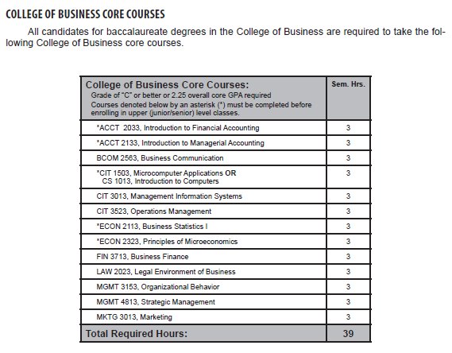
Page 133

Current page 133
*CIT 1503, Microcomputer Applications OR
CS 1013, Introduction to Computers

Change highlighted section to:
Grade of “C” or better
*CIT 1503, Microcomputer Applications OR
CS 1013, Introduction to Computers

